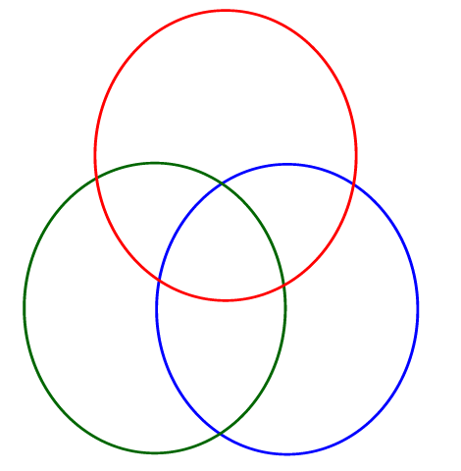
Animal Characteristics Venn Diagram Mammal Group
Mammals
Characteristics
Blood Type
Habitat
Breathing
Covering
Birthing
Examples
Non-Examples

Birds Reptiles

Animal Characteristics Venn Diagram Bird Group
Birds
Characteristics
Blood Type
Habitat
Breathing
Covering
Birthing
Examples
Non-Examples

Fish Mammals

Animal Characteristics Venn Diagram Reptile Group
Reptiles
Characteristics
Blood Type
Habitat
Breathing
Covering
Birthing
Examples
Non-Examples

Amphibians Fish

Animal Characteristics Venn Diagram Fish Group
Fish
Characteristics
Blood Type
Habitat
Breathing
Covering
Birthing
Examples
Non-Examples

Birds Reptiles

Animal Characteristics Venn Diagram Amphibian Group
Amphibians
Characteristics
Blood Type
Habitat
Breathing
Covering
Birthing
Examples
Non-Examples

Birds Reptiles

